AI-BASED FINANCIAL IDENTIFICATION BASED ON DEMOGRAPHY AND FINANCIAL FORECASTING
Design and Implementation
Product: FinSight AI
Department of Computer Science and Engineering, TKR College of Engineering and Technology (Autonomous)
Batch C9 (CSE-C) · Academic year [ACADEMIC YEAR]
Table 1: Project team
S.No. | Student name | Roll number
1 | MOHD AHMED | 23K91A05F7
2 | MANNE UPENDER | 23K91A05E6
3 | PADALA RAJESH | 23K91A05H7
4 | MADAGOUNI HARSHAVARDHAN GOUD | 23K91A05D5

Project guide: B SRIKANTH
Chapter and section numbers quoted in the text (for example Section 6.6 or Chapter 8) refer to the full project report, 17.Final Document. Figures and tables in this document are numbered from 1.

1. DESIGN

5.1 Architecture
The design follows three rules: keep the model, the explanation and the user interface separate; load heavy objects once and reuse them; and write nothing about a person to disk. The original Flask project (server-rendered pages) is kept working, and a thin JSON layer and a React interface are added on top of the same service code, so there is one source of truth for every prediction.
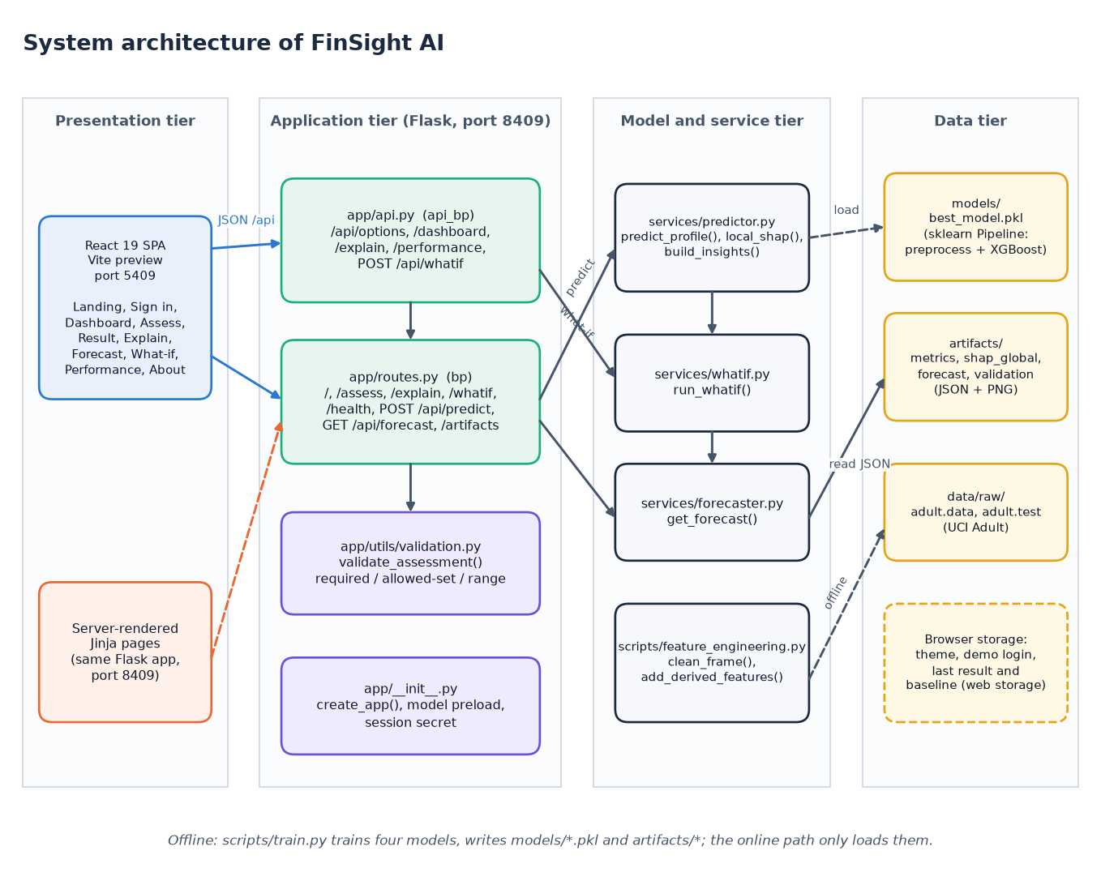
Figure 1: System architecture of FinSight AI
The system has four tiers. In the presentation tier the React single-page application (served by Vite on port 5409) and the server-rendered Jinja pages of the original Flask project are the two ways a user reaches the system. The application tier is the Flask service on port 8409: app/api.py holds the JSON routes written for the React front end, app/routes.py holds the page routes plus /api/predict and /api/forecast, app/utils/validation.py checks every input and app/__init__.py builds the application and preloads the model. The model and service tier contains predictor.py (prediction, SHAP and insights), whatif.py, forecaster.py and the shared feature_engineering.py. The data tier is made of files: the persisted pipeline in models/, the JSON and PNG artifacts, the raw census files and browser storage.

5.2 High-level workflow
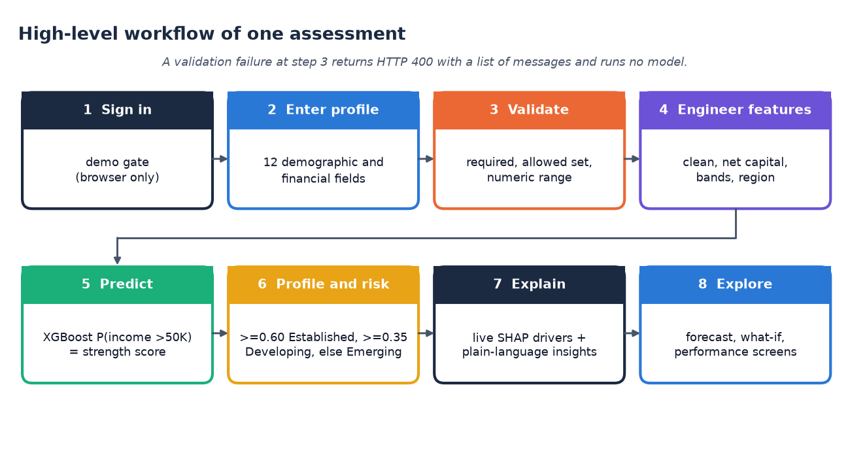
Figure 2: High-level workflow of one assessment, from sign-in to exploration
One assessment passes through eight steps. The user signs in through the demo gate and enters the twelve demographic and financial fields. The server validates that every field is present, belongs to its allowed set and lies in its numeric range; a failure ends the flow with HTTP 400 and a list of messages, and no model is run. Valid input is cleaned and extended with the derived features, and the saved XGBoost pipeline returns the probability of income above 50K, which is the financial-strength score. The probability is mapped to a profile and a risk band, and SHAP contributions plus rule-based insights explain it. The user can then open the forecast, the what-if comparison and the performance screens.

5.3 Data flow diagrams
The data flow diagrams follow Yourdon notation: circles are processes, rectangles with a bold border are external entities and open-ended rectangles are data stores.

Level 0
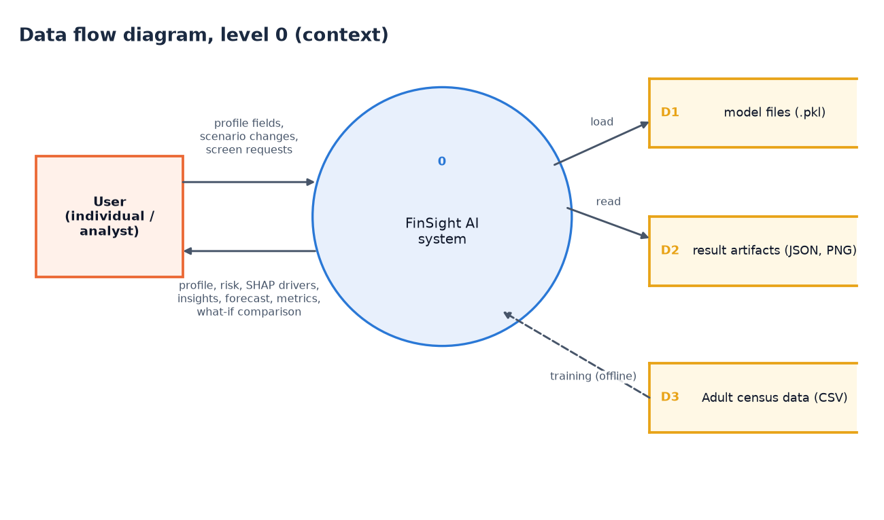
Figure 3: Data flow diagram, level 0 (context diagram)
The context diagram shows FinSight AI as one process with one external entity, the user. The user sends profile fields, scenario changes and requests for the other screens; the system returns the profile, risk band, SHAP drivers, insights, forecast, metrics and what-if comparison. Three data stores surround the process. D1 holds the trained model files, which are loaded and never modified while the application runs. D2 holds the result artifacts (metrics, SHAP importance, forecast and validation reports as JSON and PNG), which are read. D3 is the Adult census data; it is touched only by the offline training run, drawn as a dashed arrow, which is the only place where D1 and D2 are written.

Level 1
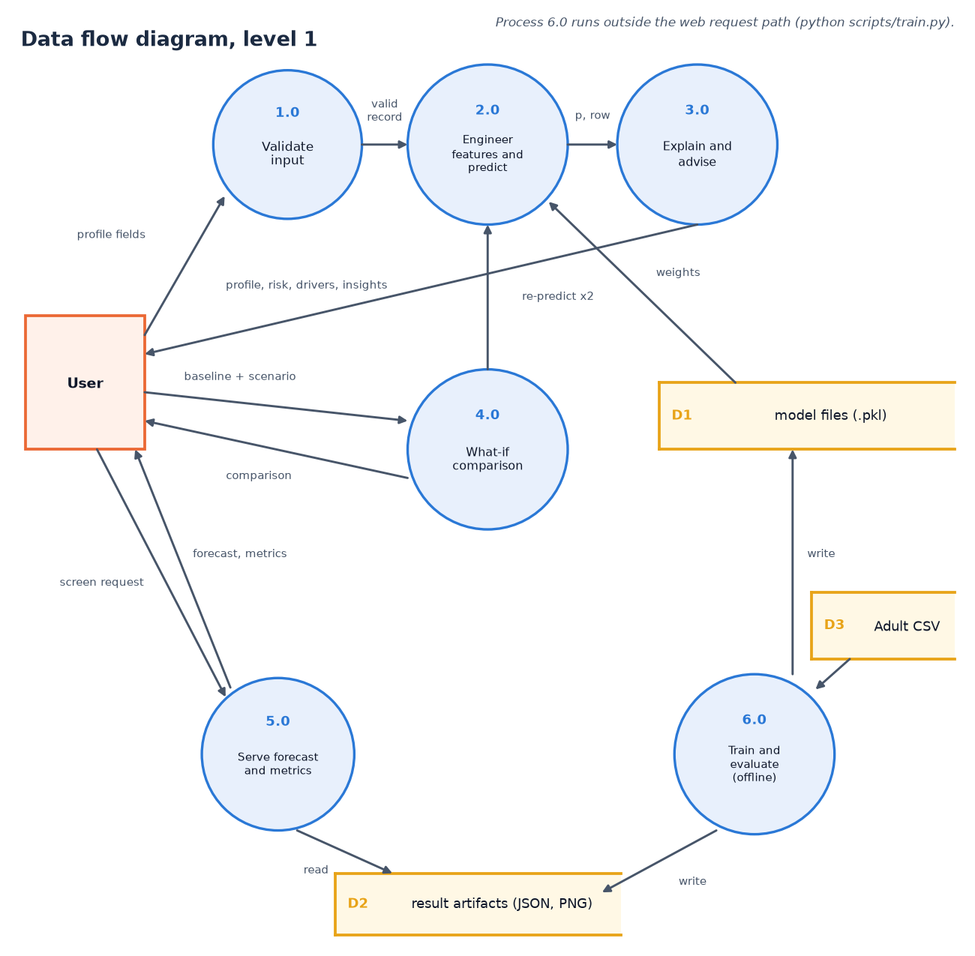
Figure 4: Data flow diagram, level 1
Level 1 splits the system into six processes. Validate input (1.0) turns the raw form values into a valid record or an error list. Engineer features and predict (2.0) builds the feature row and obtains the probability from the pipeline stored in D1. Explain and advise (3.0) computes SHAP contributions and plain-language insights and returns the profile, risk band, drivers and insights to the user. What-if comparison (4.0) receives a baseline and a scenario and calls process 2.0 twice. Serve forecast and metrics (5.0) answers screen requests by reading D2. Train and evaluate (6.0) runs offline: it reads the census data (D3) and writes the model files (D1) and the artifacts (D2).

Level 2
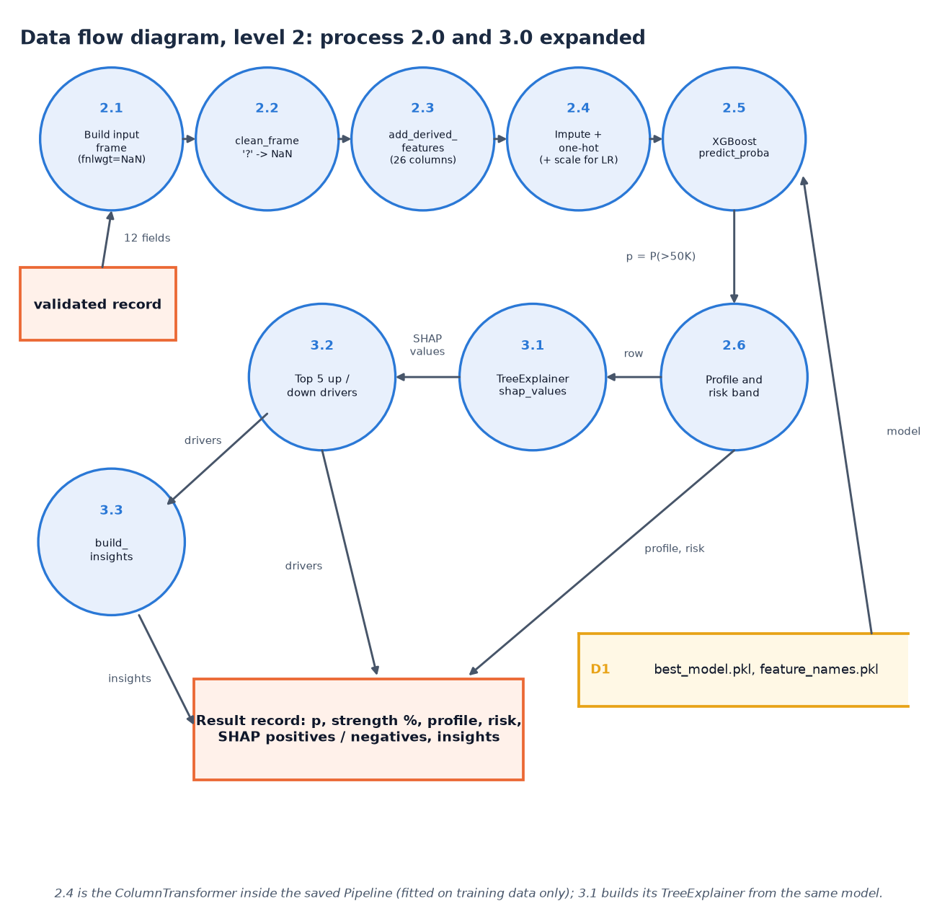
Figure 5: Data flow diagram, level 2: processes 2.0 and 3.0 expanded
Level 2 expands the prediction and explanation processes in the order the code executes them. The validated record becomes a one-row frame in which the census weight is left missing (2.1); clean_frame converts '?' markers to missing values (2.2); add_derived_features adds the net-capital, band, tier, region and stability columns, giving 26 columns (2.3); the preprocessing step of the saved pipeline imputes, one-hot encodes and, for logistic regression only, scales (2.4); XGBoost returns the probability (2.5). The probability becomes a profile and risk band (2.6). In parallel the same row goes to the TreeExplainer (3.1), the five strongest positive and negative contributions are selected (3.2) and the insight rules write the advice (3.3). All of it is assembled into one result record.

5.4 UML diagrams

Class diagram
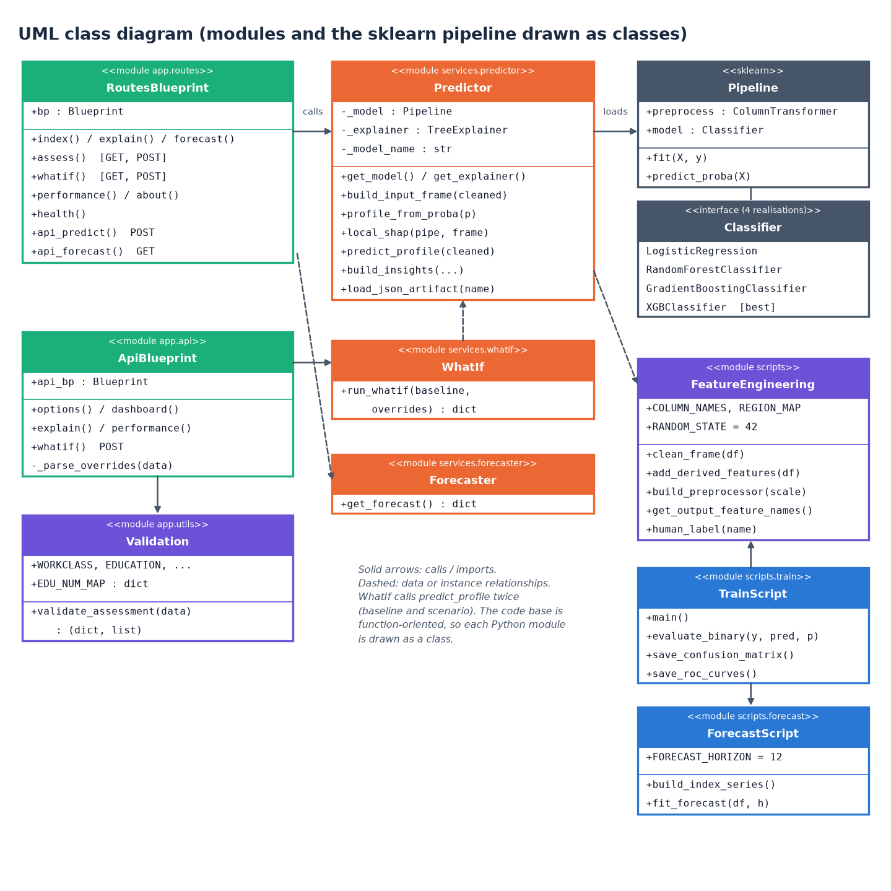
Figure 6: UML class diagram (modules drawn as classes)
The code base is function-oriented, so each Python module is drawn as a class stereotyped as a module, listing its constants and public functions. RoutesBlueprint and ApiBlueprint are the two Flask blueprints; both depend on Validation for input checking, and the routes call Predictor, which owns the cached model, the cached explainer and the prediction, SHAP and insight functions. WhatIf calls predict_profile twice, Forecaster reads the forecast artifact, and FeatureEngineering supplies cleaning, derived features and the preprocessor. A scikit-learn Pipeline combines the preprocessor with one of four classifier realisations, XGBoost being the selected one. TrainScript and ForecastScript are the offline modules.

Sequence diagram
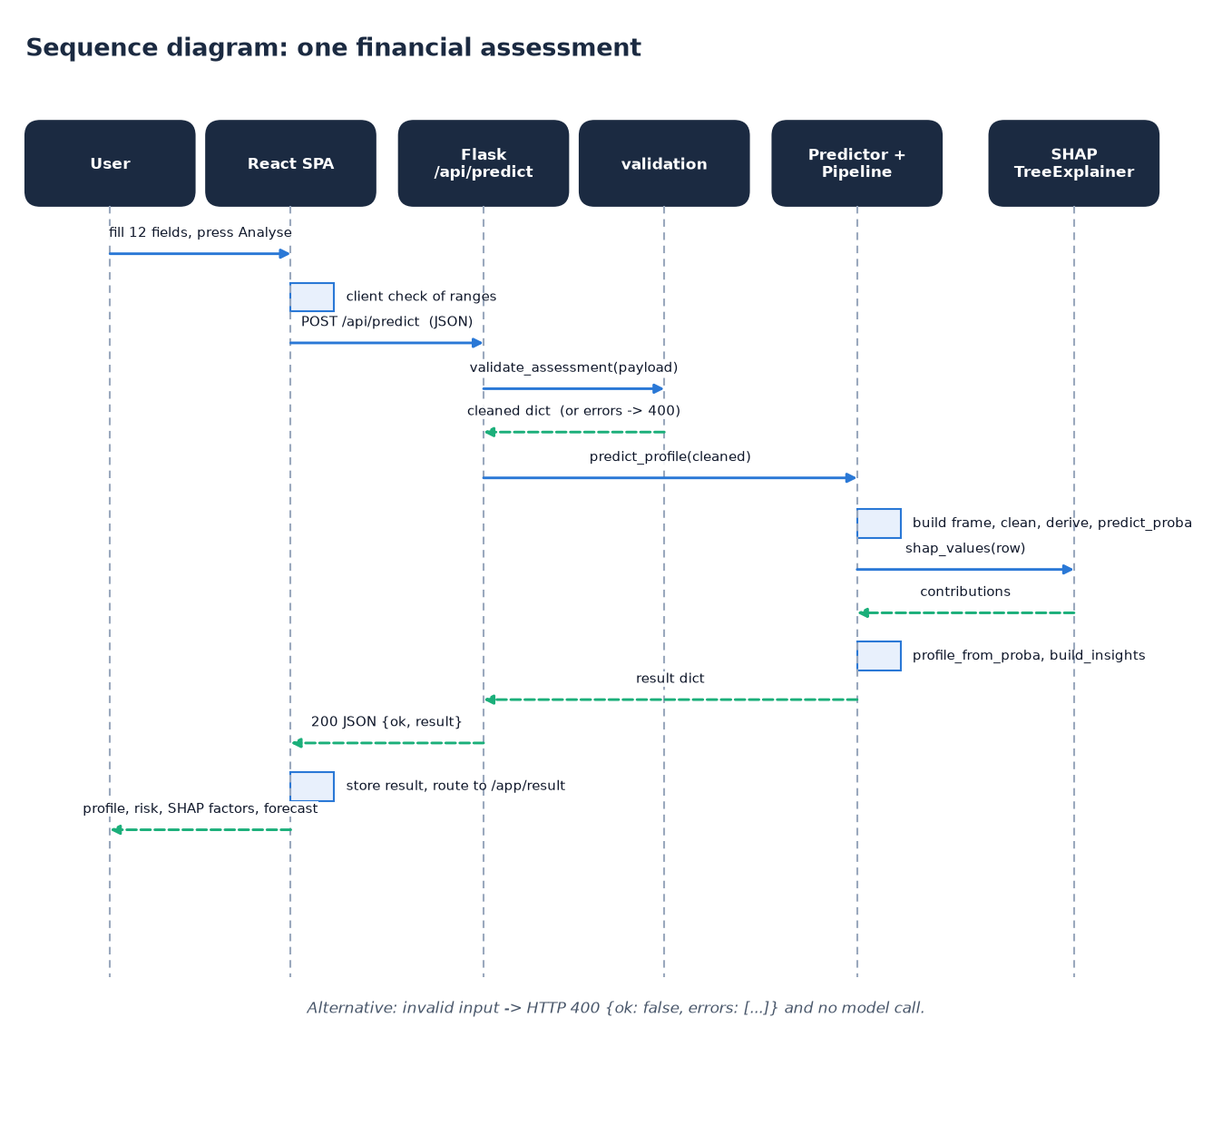
Figure 7: Sequence diagram: one financial assessment
The sequence follows one assessment. The user fills the twelve fields in the React page, which first checks the ranges in the browser and then posts the values as JSON to /api/predict. The route calls validate_assessment; on success it calls predict_profile, which builds the frame, derives the features and obtains the probability from the pipeline. It then asks the TreeExplainer for the SHAP values of that single row, maps the probability to a profile and band, and builds the insights. The result dictionary travels back as an HTTP 200 JSON body; the page stores it in the browser session and navigates to the result screen, which shows the profile, score bar, SHAP factors, insights and the forecast. Invalid input short-circuits with HTTP 400.

Use-case diagram
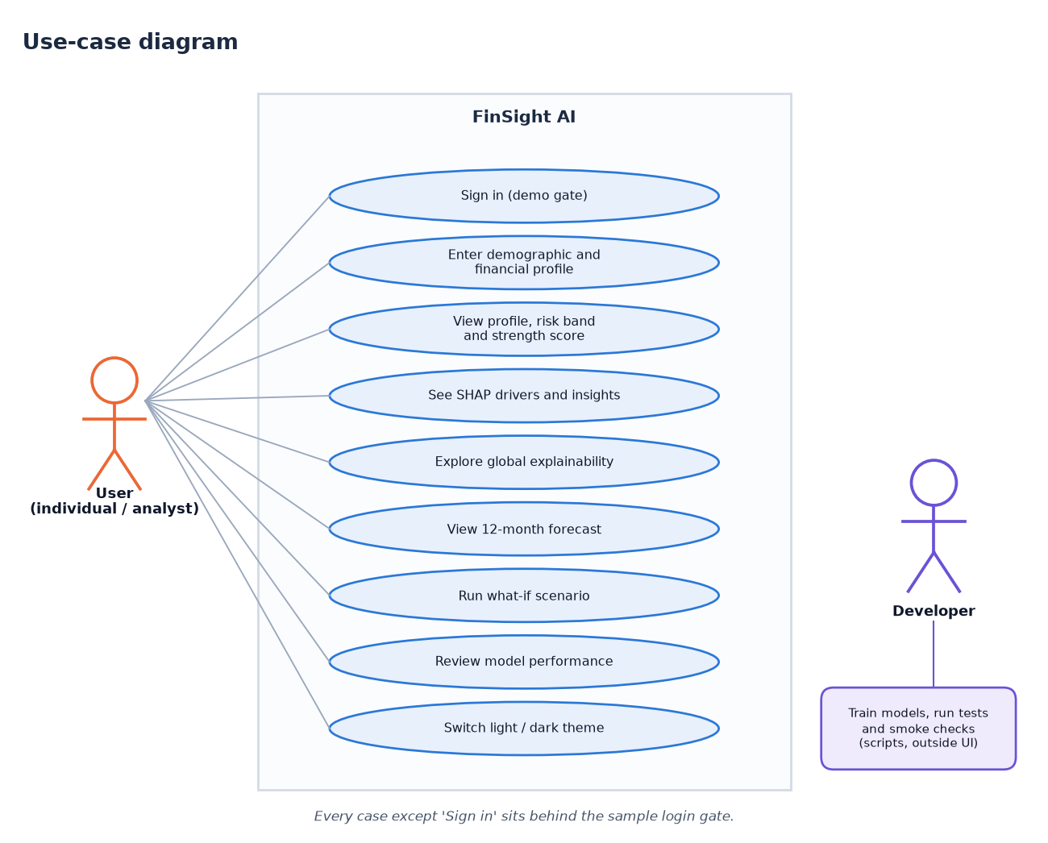
Figure 8: Use-case diagram
The user can sign in with the demo account, enter a demographic and financial profile, view the profile, risk band and strength score, read the SHAP drivers and insights, explore the global explainability charts, view the 12-month forecast, run a what-if scenario, review the model performance and switch between light and dark themes. Every case except signing in sits behind the sample login gate. The second actor, the developer, trains the models and runs the tests and smoke checks from the command line; those activities are outside the web interface and are drawn separately to show that the running application never retrains a model.

5.5 Database and data design
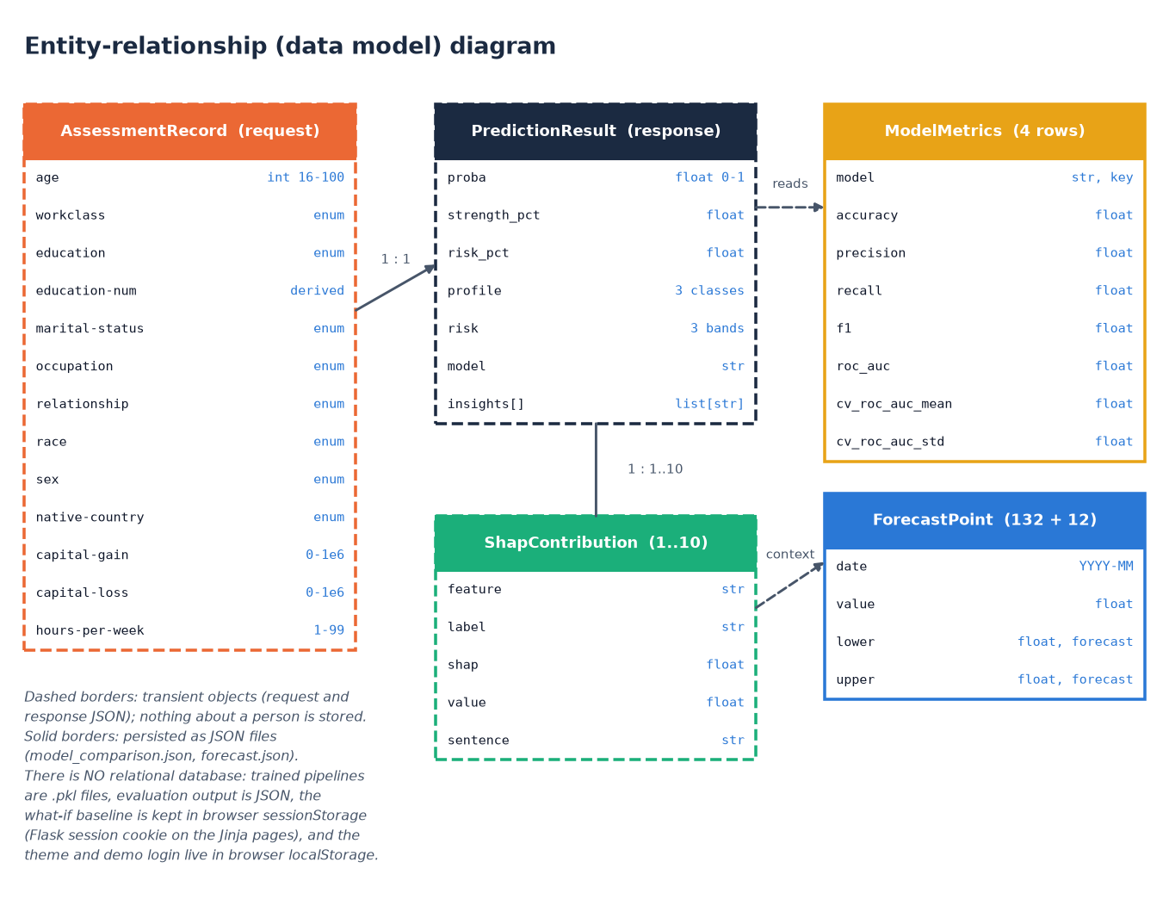
Figure 9: Entity-relationship (data model) diagram
FinSight AI has no relational database, so the diagram shows the data model instead of tables. Dashed boxes are transient objects that exist only inside one request: the assessment record (the twelve inputs, with education-num derived), the prediction result and the SHAP contributions, between one and ten per result. Solid boxes are persisted as JSON: the model-metrics rows (four models, with test and cross-validation scores) and the forecast points (132 history points and 12 forecast points). One request produces one result, which holds many SHAP items. Nothing about a person is written to disk; the what-if baseline lives only in browser or session storage.
The product has no relational database. The batch proposal mentioned MySQL, but nothing that FinSight AI handles needs to be stored: an assessment is computed from the request alone, the result is returned to the browser and then discarded by the server, and the only data that outlive a request are the trained pipelines and the evaluation artifacts, which are written once by the training script and then only read. Leaving out a database removes a whole class of risks (stored personal data, injection, schema migration) and keeps the system runnable with two commands. It also means there is no user history, no audit trail and no multi-user state; Chapter 10 lists this as future work.
Table 2: Data model of FinSight AI (transient objects and persisted files)
Entity | Fields | Type | Rule | Where it lives
AssessmentRecord | age | integer | 16 to 100 | request body only
AssessmentRecord | workclass, education, marital-status, occupation, relationship, race, sex, native-country | text (enumerations) | must belong to the allowed list in validation.py | request body only
AssessmentRecord | capital-gain, capital-loss | number | 0 to 1,000,000 | request body only
AssessmentRecord | hours-per-week | integer | 1 to 99 | request body only
AssessmentRecord | education-num | integer (derived) | looked up from EDU_NUM_MAP, 1 to 16 | added by the validator
PredictionResult | proba, strength_pct, risk_pct | float | 0 to 1; 0 to 100; 100 minus strength | response body, browser session
PredictionResult | profile, risk, model | text | Emerging / Developing / Established; Low / Moderate / High; model name | response body
PredictionResult | insights | list of text | 2 to 7 rule-generated sentences | response body
ShapContribution | feature, label, shap, value, sentence | text, text, float, float, text | up to 5 positive and 5 negative per result | response body
ModelMetrics | model, accuracy, precision, recall, f1, roc_auc, cv_roc_auc_mean, cv_roc_auc_std | text and floats | one row per model, four rows | artifacts/model_comparison.json
ForecastPoint | date, value, lower, upper | text and floats | 132 history points, 12 forecast points with a 95% band | artifacts/forecast.json
Pipeline | preprocess + model | scikit-learn object | one pickle per candidate and best_model.pkl | models/*.pkl

All trained objects are stored with joblib. The pickles record the scikit-learn and XGBoost versions that wrote them, so loading them under a newer release prints a version warning; the metrics were re-derived with the newer release and match the stored values exactly, but a production deployment should re-train and pin versions.

5.6 Module design
Each module has one responsibility and the dependencies point in one direction: routes call services, services call the feature-engineering code and the saved pipeline, and nothing in the online path imports the training script. The table below lists the modules and the public functions they offer.
Table 3: Modules of FinSight AI and their responsibilities
Module | Public functions | Responsibility
app/__init__.py | create_app() | Application factory: reads the secret key and port, preloads the model, registers both blueprints.
app/routes.py | index, assess, explain, forecast, whatif, performance, about, health, api_predict, api_forecast, error handlers | Server-rendered pages, health check, /api/predict, /api/forecast, whitelist of served artifact images.
app/api.py | options, dashboard, explain, performance, whatif, _parse_overrides | Thin read-only JSON layer for the React front end; adds /api/whatif.
app/utils/validation.py | validate_assessment(), option lists, EDU_NUM_MAP | Required, allowed-set and numeric-range checks; returns a cleaned dictionary or a list of messages.
app/services/predictor.py | get_model, get_explainer, build_input_frame, profile_from_proba, local_shap, predict_profile, build_insights, load_json_artifact | Prediction, profile and risk mapping, live SHAP, plain-language insights and artifact loading.
app/services/whatif.py | run_whatif() | Predicts a baseline and a changed scenario and reports the score change and the verdict.
app/services/forecaster.py | get_forecast() | Loads the forecast artifact and flags it unavailable when it is missing.
scripts/feature_engineering.py | clean_frame, add_derived_features, build_preprocessor, get_output_feature_names, human_label | Cleaning, 12 derived features, the leakage-safe ColumnTransformer and readable feature names.
scripts/models.py | get_candidate_models() | The four classifiers and their hyperparameters.
scripts/train.py | main, evaluate_binary, save_confusion_matrix, save_roc_curves | Offline training, cross-validation, selection, SHAP artifacts, plots, reports.
scripts/forecast.py | build_index_series, fit_forecast | Synthetic index series and the Holt-Winters forecast.
scripts/report_metrics.py | main | Re-derives confusion matrices, threshold sweep, calibration and the forecast back-test.
tests/, scripts/smoke_test.py | test_app.py, test_features.py | Nine automated tests and a 35-check live smoke test.
frontend/src/ | 11 pages, lib/, components/ | The React interface: routing, API client, theme, auth gate and charts.

5.7 User interface design
The React interface follows a calm, pastel design kit: a warm off-white page background, white cards with soft shadows, six pastel accents (lavender, mint, peach, sky, rose and butter) used to tell sections apart, and Plus Jakarta Sans for headings with Inter for body text. All colours, radii, shadows and the sidebar and top-bar sizes are CSS custom properties on :root, and a dark theme overrides the same tokens under data-theme="dark". The theme follows the operating system until the user presses the toggle, after which the choice is kept in browser storage.
The interface has eleven routes: a landing page, a sign-in page and, behind the sign-in gate, the dashboard, assessment, result, explainability, forecast, what-if, performance and about pages, plus a not-found page. Pages are loaded lazily, so the first load carries only the shell. A fixed sidebar with colour-coded icons gives navigation on screens of 900 pixels and wider; below that it is replaced by a bottom bar and a drawer, and the form and card grids collapse to one column below 1,000 pixels. Loading states use skeletons, results arrive with short spring animations, toasts confirm actions, errors are shown above the form with the offending field marked aria-invalid, and focus moves to the first invalid field.
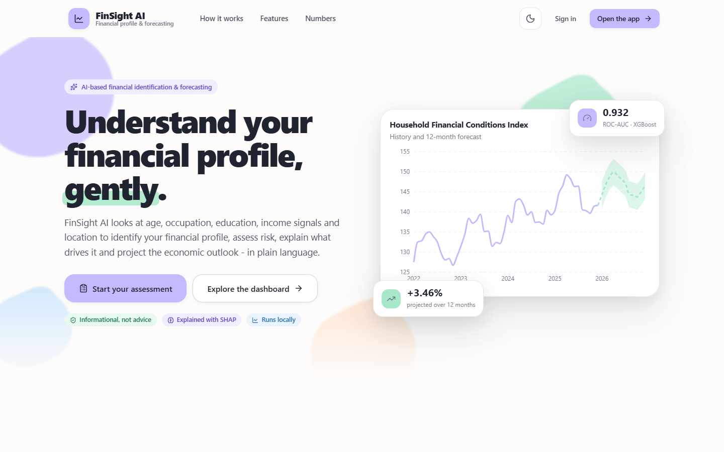
Figure 10: Landing page of the React interface (light theme)
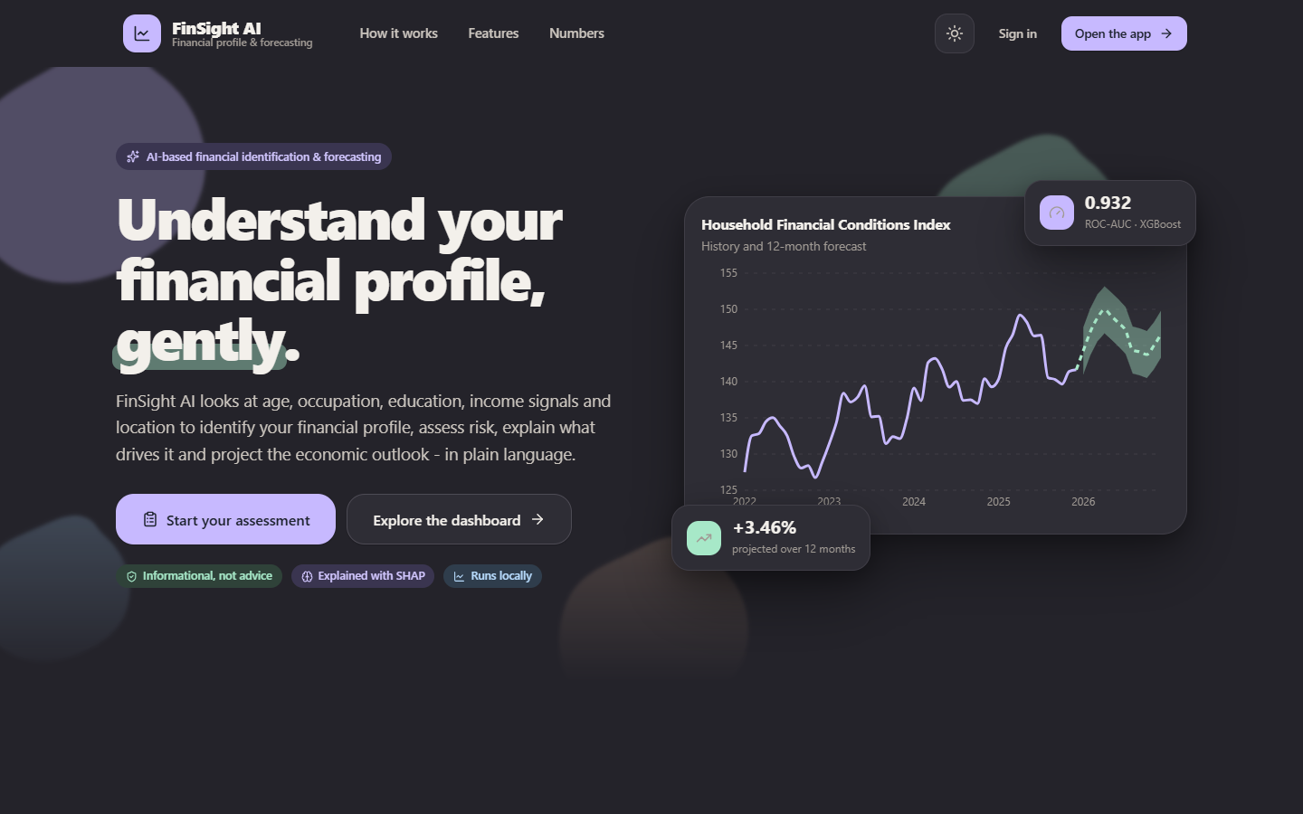
Figure 11: The same landing page in the dark theme
Signing in is a demo gate, not authentication. The login page offers a sample account (demo@finsight.ai) with a button that fills the credentials; the check runs in the browser, the user record is kept in browser storage and the guarded routes redirect signed-out visitors to the login page and return them to the page they asked for. The product stores no accounts, so there is nothing for a real login to protect; the gate exists so that the interface looks and behaves like a product, and Section 6.9 states this limit.
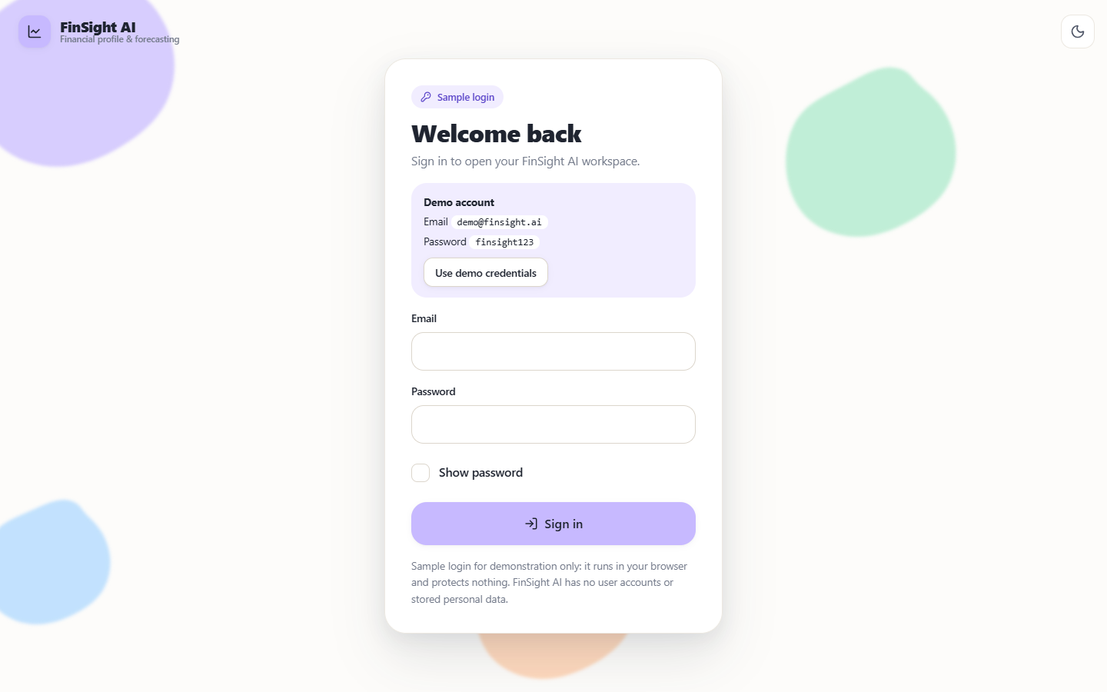
Figure 12: Sign-in page with the sample account
The assessment form groups the twelve inputs in a four-column grid with a label, a unit or range hint under each field, validation on submit and an option to fill a sample profile. Results are shown as a profile badge, a risk badge, a score bar, strengthening and weakening SHAP factors, actionable insights, an echo of the inputs and a mini forecast chart.
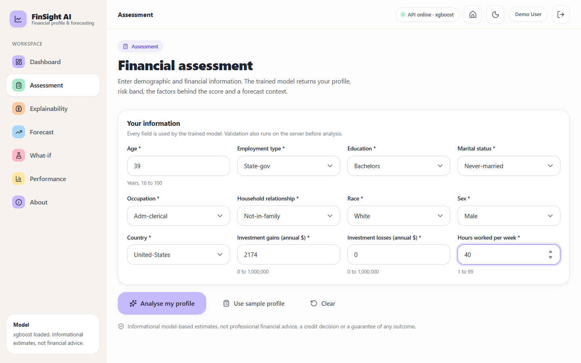
Figure 13: Assessment form filled with a sample profile

5.8 Core algorithm and training pipeline
The core algorithm is the prediction endpoint. Its decision logic is short on purpose: validate, build the frame, derive the features, call predict_proba, compare the probability with two fixed cut-offs, explain and return. The cut-offs 0.60 and 0.35 are design choices of this project, not learned values; on the test split they separate three groups whose observed share of income above 50K is 7.2%, 44.0% and 85.2% (Chapter 8).
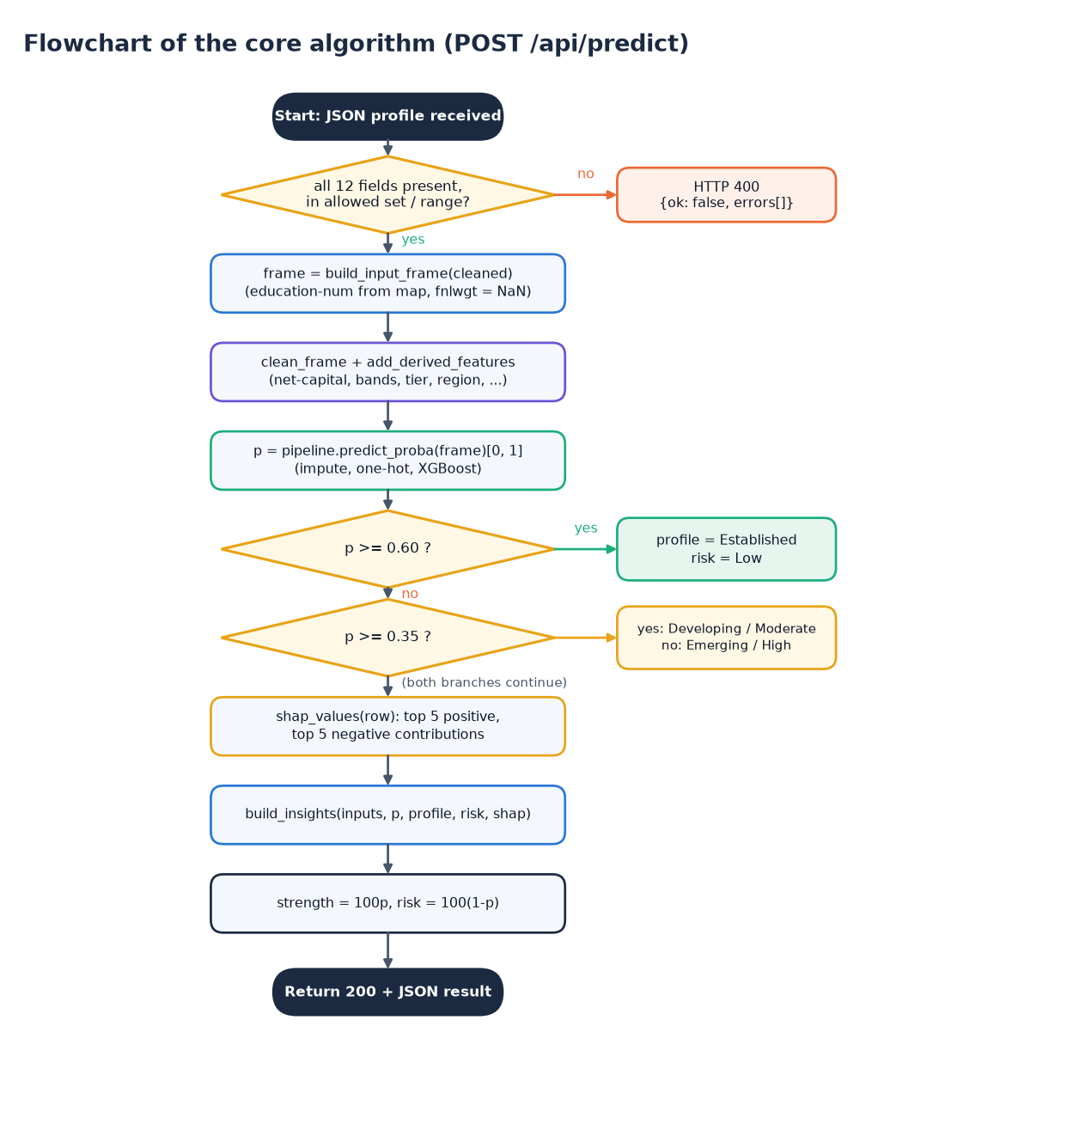
Figure 14: Flowchart of the core algorithm (POST /api/predict)
The flowchart gives the decision logic of the prediction endpoint. A JSON profile is received and validated; a missing, disallowed or out-of-range field returns HTTP 400 with the error list. Otherwise the input frame is built (education-num looked up from the education level, census weight left missing), the cleaning and feature-derivation functions run, and predict_proba returns the probability p of income above 50K. Two comparisons decide the label: p of at least 0.60 gives Established with Low risk, p of at least 0.35 gives Developing with Moderate risk, and anything lower gives Emerging with High risk. The SHAP contributions and insights are then computed, strength is set to 100p and risk to 100(1-p), and a 200 response is returned.
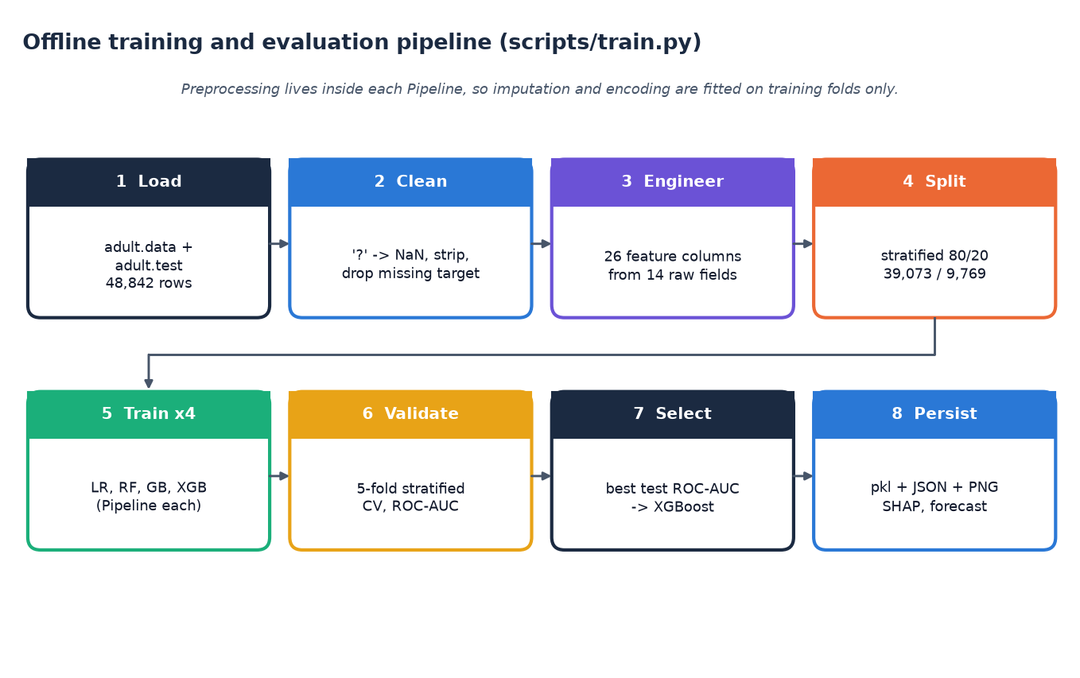
Figure 15: Offline training and evaluation pipeline (scripts/train.py)
Training is a separate offline script with eight steps. It loads adult.data and adult.test (48,842 rows), cleans them ('?' to missing, whitespace stripped, rows without a target dropped), engineers 26 feature columns from the 14 raw fields, and makes a stratified 80/20 split (39,073 training and 9,769 test rows). Each of four classifiers is wrapped in its own Pipeline together with its preprocessor, scored by 5-fold stratified cross-validation on the training split and then fitted and evaluated on the test split. The model with the highest test ROC-AUC is selected, and the pickles, JSON reports, charts, SHAP importance and forecast are persisted for the web application to load.

5.9 Design decisions and trade-offs
Several decisions shaped the design. Each was a trade-off between simplicity, honesty about the data and the objectives in the project proposal, and the table records the alternative that was rejected and why.
Table 4: Design decisions and their reasons
Decision | Alternative considered | Reason for the choice
Serve the saved scikit-learn Pipeline, not a separate preprocessor and model | Pickle the model and re-implement encoding in the service | One object guarantees that serving applies exactly the preprocessing that was measured; no training-serving skew
Compute SHAP live for every request with tree_path_dependent | Pre-compute explanations or use a background sample | Exact per-person attributions without extra data, at a median cost of tens of milliseconds
Fixed profile cut-offs of 0.60 and 0.35 | Learn the bands from quantiles or a third model | Easy to explain and to audit; the observed share of income above 50K rises monotonically across the three bands
No database | SQLite or MySQL for assessment history | Nothing needs to persist; avoids storing personal data; history is listed as future work
Thin JSON layer in app/api.py over the existing services | Rewrite the back end as a new service | No duplicated logic; the original pages keep working and both front ends call the same functions
Forecast on a separate synthetic index | Pretend the census data can be forecast, or download a real indicator | The census rows carry no time; a documented synthetic series lets the method be shown honestly and be replaced later
Sample login in the browser | Server-side accounts | There are no accounts or stored data to protect; real authentication is deferred

Two design choices keep the evaluation honest. First, imputation, one-hot encoding and scaling live inside the Pipeline, so cross-validation refits them on each training fold and no information from a validation fold reaches the preprocessing step, which is the leakage the base paper [1] guards against with entity-level folds. Second, the same Pipeline object is used for training, evaluation and serving, so the model that was measured is the model that answers requests.

2. IMPLEMENTATION

6.7 Application architecture and what-if logic
create_app() builds the Flask application, reads the session secret from the environment, preloads the persisted pipeline so that the first request is as fast as later ones, and registers the two blueprints. A failed preload is logged as a warning and the application still starts; /health then reports degraded and prediction routes return an explanatory error until the model is trained.
predict_profile(cleaned) is the heart of the service. It builds a one-row frame from the validated record, applies clean_frame and add_derived_features, calls predict_proba on the cached pipeline, maps the probability with profile_from_proba, asks local_shap for the contributions and build_insights for the advice, and returns one dictionary. The TreeExplainer is built lazily on first use with feature_perturbation="tree_path_dependent", which needs no background data and keeps each request fast.
def profile_from_proba(p: float) -> tuple:
"""Map P(income>50K) to (profile, risk_level)."""
if p >= 0.60:
return "Established", "Low"
if p >= 0.35:
return "Developing", "Moderate"
return "Emerging", "High"

local_shap transforms the row with the pipeline's preprocessor, computes SHAP values for the single row, keeps the eight most negative and eight most positive, and returns the five strongest of each sign. Each item carries a human-readable label and a sentence. One-hot columns need care: for a feature such as occupation = Sales a value of 0 means the category does not apply, so the sentence reads "absence of occupation = Sales ..." instead of claiming the opposite. Failures are caught and returned as a note, so an explanation problem never blocks the prediction.
build_insights is rule-based and independent of SHAP: one message per profile, extra messages when weekly hours are below 35, when gains or losses are reported or when education is at or below high-school level, a sentence quoting up to four SHAP drivers and always a closing disclaimer. Because the rules look only at the inputs, an insight can disagree with the SHAP sign for the same person (for a never-married 39-year-old with gains of 2,174 the rule says gains are a positive signal while SHAP assigns them a contribution of -1.63, because the rule is fixed text keyed on the input and SHAP reflects what the model learned). This is a known weakness of mixing two explanation sources and is listed as future work.
What-if comparison. run_whatif(baseline, overrides) predicts the baseline, copies the record, replaces the overridden fields (investment gains, investment losses, weekly hours, education with its numeric equivalent), predicts again and reports the change in probability. A change above +0.02 is described as an improvement, below -0.02 as a decline and anything in between as roughly unchanged; the response also lists the changed fields and whether the profile or risk band changed. The verdict always ends with the warning that this is a model simulation, not a causal prediction. At least one scenario field must be supplied, and the scenario values obey the same ranges as the form. The React pages keep the baseline in the browser session; the original Flask pages keep it in the Flask session cookie.
Forecast service. get_forecast() loads artifacts/forecast.json (history, fitted values, 12 forecast points with lower and upper bounds, direction, percentage change and an interpretation sentence) and returns an available: false structure if the file is missing, so the interface degrades gracefully.
Front end. The React application talks to the API through one small client (lib/api.js) that wraps fetch, converts failures into an ApiError carrying the server's message list, and exposes one function per endpoint. Pages load data with a useAsync hook and show a skeleton, an error message or the content. Charts are drawn with Recharts and follow the active theme. In development and preview, Vite proxies /api, /artifacts and /health to port 8409, so the browser talks to one origin and no cross-origin configuration is needed.

6.8 API design
All routes are served by Flask on port 8409 (and through the Vite proxy on 5409). JSON routes return {ok, result} on success and {ok: false, errors: [...]} with status 400 or 500 on failure. The page routes return HTML and are kept for the original interface.
Table 5: Endpoints of FinSight AI
Method and path | Request | Response | Errors
POST /api/predict | JSON with the 12 assessment fields | {ok, result}: proba, strength_pct, risk_pct, profile, risk, model, inputs, shap, insights | 400 validation list; 500 model missing or failure
POST /api/whatif | the 12 fields plus scenario_capital_gain, scenario_capital_loss, scenario_hours, scenario_education (at least one) | {ok, result}: baseline, scenario, changed, delta, delta_pct, verdict, profile_changed, risk_changed | 400 for bad input, no scenario field or out-of-range value; 500
GET /api/forecast | none | history, fitted, 12 forecast points with bounds, method, trend, interpretation | always 200; available: false if missing
GET /api/options | none | option lists for the seven dropdowns and the numeric limits | -
GET /api/dashboard | none | model name, metrics, top-5 SHAP, outlook, training summary | -
GET /api/explain | none | global SHAP importance (top 15) | -
GET /api/performance | none | model comparison, validation report, statistics, training summary | -
GET /health | none | status ok or degraded, model name, model_loaded, forecast_available | -
GET /artifacts/<name> | one of four PNG names | confusion matrix, ROC, SHAP bar or beeswarm image | 404 for any other name
GET, POST /, /assess, /explain, /forecast, /whatif, /performance, /about | form fields for the two POST pages | server-rendered HTML pages | 400 / 500 re-render the form with messages; 404 page

Example of a successful /api/predict response for the first record of the Adult file (a 39-year-old state employee with a bachelor's degree, never married, gains of 2,174, 40 hours per week); the arrays are abbreviated:
{"ok": true,
"result": {"proba": 0.0109, "strength_pct": 1.1, "risk_pct": 98.9,
"profile": "Emerging", "risk": "High", "model": "xgboost",
"inputs": {...12 fields + education-num...},
"shap": {"available": true, "expected_value": -1.1765,
"positives": [{"feature": "education-num", "label": "Years of education",
"shap": 0.545, "value": 13.0, "sentence": "..."}, ...],
"negatives": [{"feature": "capital-gain", "shap": -1.6264, ...}, ...]},
"insights": ["...", "..."]}}

Example of a failed request with the age set to -5: HTTP 400 and {"ok": false, "errors": ["Age must be between 16 and 100."]}.

6.9 Security and error handling
The application is a local research prototype and its security is deliberately modest; the measures that exist are listed together with their limits.
• Input validation. validate_assessment requires every field, restricts the seven categorical fields to fixed allowed lists and checks the numeric fields for type and range (age 16-100, hours 1-99, gains and losses 0-1,000,000). Because values are only ever compared with allowed lists or converted to numbers and the application has no database, shell call or template that echoes raw input into code, injection through the form is not a realistic path.
• Error paths. Invalid input returns HTTP 400 with every message at once; a missing model file or a failure inside prediction returns 500 with a safe message while the stack trace goes to the log; unknown URLs and server errors render a friendly error page; the React client shows the first message in a toast and the full list above the form.
• What is exposed. /artifacts/<name> serves only four whitelisted PNG names; the process binds to 127.0.0.1, so it is reachable only from the same machine; Flask debug mode is off.
• No personal data is stored. Inputs are used for one computation; the what-if baseline is held in the browser session (React) or the signed Flask session cookie (original pages).
• Demo login. The sign-in gate is client-side and its credentials are shown on the login page. It is not authentication and protects nothing; real accounts, hashed passwords and server-side sessions are future work.
• Secrets. The Flask secret key is read from FINSIGHT_SECRET_KEY and falls back to a fixed development value, which must be replaced in any shared deployment.
• Transport and abuse. Traffic is plain HTTP on localhost, there is no rate limiting, and the Flask development server is not meant for production; a WSGI server and a reverse proxy with TLS would be required.

6.10 Installation and execution
The project needs Python 3.11 or newer and Node.js 18 or newer. The measured environment was Windows 11 Pro, Intel Core i5-12500 (12th Gen), 15.7 GB RAM, Python 3.11.9, scikit-learn 1.9.1, XGBoost 3.2.0, SHAP 0.51.0, statsmodels 0.15.0, Flask 3.1.3 and Node 24.19.0; no GPU is used. requirements.txt lists 12 packages (pandas, numpy, scikit-learn, xgboost, shap, statsmodels, Flask, joblib, matplotlib, pytest, requests and fpdf2).
Automatic. Double-clicking run.bat reads the ports from .env (API 8409, front end 5409), creates .venv, installs the requirements, trains the models if models/best_model.pkl is missing, runs npm install and npm run build on the first run, starts the API in a second window, opens the browser and serves the built front end with npm run preview.
Manual.
python -m venv .venv
.venv\Scripts\activate
pip install -r requirements.txt
python scripts\train.py # only if models\best_model.pkl is missing
python run.py # API on http://localhost:8409

cd frontend
npm install
npm run dev # http://localhost:5409 (proxies /api to 8409)
# production-style: npm run build then npm run preview

Sign in with the sample account demo@finsight.ai and password finsight123 (the login page has a button that fills them). The original server-rendered pages remain available at http://localhost:8409.
Checks. pytest runs 9 tests (seven in tests/test_app.py covering health, page loading, input-dependent predictions, validation errors, the JSON API, the what-if route and artifact presence, and two in tests/test_features.py covering the derived features and missing-value handling) in about 9 seconds. With both servers running, python scripts/smoke_test.py performs 35 live checks of the API and the proxy, and python scripts/capture_screens.py walks every screen with Playwright and fails on any console error. A single prediction takes a median of 68.9 ms (95th percentile 116.9 ms) and a what-if comparison 136.1 ms when measured on 127.0.0.1 over 40 calls.

3. KEY CODE WALK-THROUGHS
Four pieces of code carry the method. Each is shown as it exists in the repository and explained in turn.

1. From a probability to a profile and a risk band
def profile_from_proba(p: float) -> tuple:
"""Map P(income>50K) to (profile, risk_level)."""
if p >= 0.60:
return "Established", "Low"
if p >= 0.35:
return "Developing", "Moderate"
return "Emerging", "High"

The classifier returns P(income > 50K). The application reads it as a financial-strength score and applies two fixed cut-offs, 0.60 and 0.35, to name the profile and the risk band. The cut-offs were chosen for a readable three-band output and were not tuned; the test split shows that the bands do separate people (observed income-above-50K rates of 7.2%, 44.0% and 85.2% for Emerging, Developing and Established).

2. The prediction pipeline
def predict_profile(cleaned: dict) -> dict:
"""Full prediction pipeline for one validated input dict."""
_ensure_scripts_path()
from feature_engineering import clean_frame, add_derived_features
pipe = get_model()
frame = build_input_frame(cleaned)
frame = add_derived_features(clean_frame(frame))
try:
proba = float(pipe.predict_proba(frame)[0, 1])
except Exception as e:
raise RuntimeError(f"Prediction failed: {e}")
profile, risk = profile_from_proba(proba)
shap_local = local_shap(pipe, frame)
insights = build_insights(cleaned, proba, profile, risk, shap_local)
return {
"proba": round(proba, 4),
"strength_pct": round(proba * 100, 1),
"risk_pct": round((1 - proba) * 100, 1),
"profile": profile,
"risk": risk,
"model": get_model_name(),
"inputs": cleaned,
"shap": shap_local,
"insights": insights,
}

predict_profile builds a one-row frame from the validated input (leaving fnlwgt missing so that the pipeline imputes the training median), applies the same clean_frame and add_derived_features used in training, calls predict_proba on the persisted pipeline and then adds the SHAP explanation and the written insights. Because imputation and one-hot encoding are inside the pipeline, no separate transformation code can drift from training.

3. Reading SHAP values for one-hot features
def _sentence(d, direction):
base = d["label"]
v = d.get("value")
if v is not None and abs(v) < 1e-9 and "=" in base:
state = "absence of " + base
elif v is not None and abs(v - 1.0) < 1e-9 and "=" in base:
state = base + " (applies to you)"
else:
state = base
verb = ("pushes the prediction toward a stronger financial profile."
if direction == "up" else
"pulls the prediction toward a weaker financial profile.")
return f"{state} {verb}"

A one-hot column that equals 0 means the category does not apply. Saying that occupation = Prof-specialty weakens the score would be wrong for a person who is not a professional, so the sentence says absence of the category, and says applies to you when the value is 1. The five largest positive and five largest negative contributions are returned.

4. The forecast
model = ExponentialSmoothing(
series, trend="add", seasonal="add", seasonal_periods=12,
initialization_method="estimated",
)
fit = model.fit(optimized=True)
fc = fit.forecast(horizon)

An additive-trend, additive-seasonality Holt-Winters model with a 12-month period is fitted to the 132-month synthetic index. The 95% band is the point forecast plus or minus 1.96 times the standard deviation of the in-sample residuals, which is an approximation that ignores growth of uncertainty with the horizon.

4. IMPLEMENTATION DECISIONS AND THEIR REASONS
The main implementation decisions, with the reason for each, are collected below. Where a choice was a convenience rather than a measured improvement the table says so.
Table 6: Implementation decisions and reasons
Decision | Choice | Reason
Prediction target | Income above 50K, read as a profile signal | The only public, large, labelled dataset with demographic and financial attributes; clearly not a credit label
Model set | Logistic Regression, Random Forest, Gradient Boosting, XGBoost | Mirrors the base paper's families; the linear model is an interpretable floor, the boosted trees are the likely best
Selection metric | Test ROC-AUC | Threshold-free and insensitive to the 24% positive rate; cross-validated AUC gives the same ordering
Where preprocessing lives | Inside each scikit-learn Pipeline | Imputation and encoding are fitted on training data only, and identical at prediction time
Imputation | Median for numbers, constant 'Unknown' for categories | The Adult data mark missing workclass, occupation and country with '?'; 'Unknown' keeps that information
Splitting | Stratified 80/20 plus 5-fold stratified CV | One row per person, so no entity grouping is needed; stratification keeps the class ratio
Explainer | SHAP TreeExplainer, tree-path-dependent | Exact for tree models and fast enough to run on every request
Profile cut-offs | 0.60 and 0.35 on the probability | Readable three bands; not tuned; checked against observed rates in Chapter 8
Forecast data | Synthetic index, Holt-Winters | The census data have no time axis; the series is labelled synthetic in the code, the README and the UI
What-if | Re-run the same pipeline on an edited copy | No second model to keep in step; labelled non-causal
Interface | React front end proxying to the Flask API; Jinja pages kept | A modern interface without changing the working back end; both run from run.bat
Login and storage | Client-side demo gate, session storage, no database | The product holds no personal data; real authentication was out of scope

Decisions that were made without measurement and could change the results are the fixed hyperparameters, the profile cut-offs and the choice of Holt-Winters over other smoothing or ARIMA-type models.

